**As-Level Chemistry, OCR Examination Board.**

**St Patrick’s Day Double Lesson (2 Hours). Week of 23rd March**

*Green Chemistry and Greenhouse gases.*

**Student Resource**

**It is St Patrick’s Day and over the next 2 hours of lesson time you will be exploring Your Green Chemistry Module in F322. In the first part of this lesson, you will use your mole calculation skills to design a reaction to produce carbon dioxide gas. In the second part of the lesson, you will prove that it is a greenhouse gas, and absorbs IR radiation.**

**Background:**

Infra-red radiation is heat; it is what we feel on a hot summer’s day. Carbon dioxide, water and methane are greenhouse gases present in the atmosphere, and when exposed to Infra-Red radiation they absorb heat, and their bonds vibrate storing the energy. These bonds re-emit the radiation and this process keeps the earth’s surface warm and habitable for humans, the overall process is known as the greenhouse effect. Nitrogen, oxygen and argon which make up the bulk of the atmosphere do not absorb IR radiation.

The greenhouse factor of a gas measures it’s capability to absorb IR radiation compared to the same quantity carbon dioxide. Methane and water have a higher greenhouse factors than carbon dioxide but have a lower abundance so their overall contribution to the greenhouse effect is lower.

Burning of fossil fuels and cutting back rainforests is leading to a higher atmospheric carbon dioxide concentration. The Mauna Loa laboratory in Hawaii monitors atmospheric gas concentrations by IR spectroscopy. It is particularly striking to see the annual rise in carbon dioxide gas from their published results, these can be viewed on their webpage.

**Overview – you will be working in pairs for all experimental part**

**Lesson 1:**

Acid + Metal Carbonate Water + **Carbon dioxide** + Metal Salt

You will use either lemon juice or vinegar as a sustainable naturally sourced acid in a reaction with sodium carbonate (your teacher may give you washing soda instead).

Using Vinegar (A source of Acetic Acid – CH3COOH)

Na2CO3 + 2CH3COOH 2CH3COONa + H2O + **CO2**

Using Lemon Juice (A source of Citric Acid – C6H7O8)

3Na2CO3 + 2C6H8O7 2Na3(C6H5O7) + 3H2O + **3CO2**

1. You must titrate your acid to work out its concentration using 0.1 M NaOH.

* Fill your burette with 0.1 M NaOH.
* Add 25 mL of distilled water to 2 mL of vinegar/ lemon juice and 5 drops of phenolphthalein indicator.
* Perform the titration 3 times to see if results are coherent, and record a reliable average.

1. (IF APPLICABLE) You must titrate your washing soda to work out its percentage by mass of sodium carbonate.

* Fill your burette with 0.1 M HCl
* Add 25 mL of distilled water to 0.200g of Washing Soda and 5 drops of phenolphthalein indicator (this time you are recording when the indicator colour goes from pink to colourless.)
* Perform the titration 3 times to see if results are coherent, and record a reliable average.

1. **Work out the concentrations of acid and (IF APPLICABLE) the percentage by mass of sodium carbonate in washing soda. Ensure that your equations are balanced and take note of the stoichiometry.**
2. You need to aim to generate 150 mL of carbon dioxide (assuming 100% yield) so work out the amount of vinegar(/lemon juice) you need to add to sodium carbonate/(washing soda) in order to do this.

Additional Questions:

* What is the atom economy of the reaction you are planning?
* Which has a better atom economy - the reaction with lemon juice or with vinegar?
* Suggest 3 different metal carbonates that would give a better atom economy to the process, justify your answers with an equation and calculation.
* The density of Ethanoic acid is 1.05 g/L, the bottle of vinegar is 5 % by volume acetic acid and its total volume is 568 mL, do your results agree with this value? *Hint: use the density to work out the number of moles in a vinegar bottle filled with pure acetic acid.*

|  |  |
| --- | --- |
|  |  |

*Finish all Questions for Homework*

**Lesson 2:**

*This procedure will require good teamwork; it cannot be carried out alone.*

1. Accurately measure out the volume of vinegar (/lemon juice) and mass of sodium carbonate (/washing soda).
2. Place the carbonate in a small vial and pour the vinegar(/lemon juice) into a balloon

* Slightly inflate the balloon then place it over the top of the measuring cylinder.
* When the balloon is full with vinegar, carefully release the air.
* Tie the balloon with a piece of string and then attach it to the vial with a rubber band/ cable tie.
* Untie the string and shake up and the balloon will inflate with carbon dioxide gas.

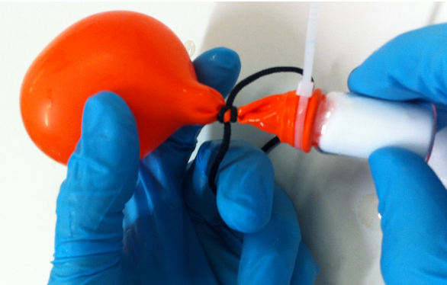

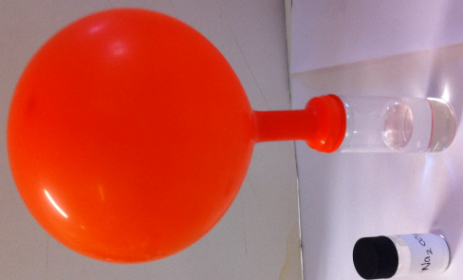

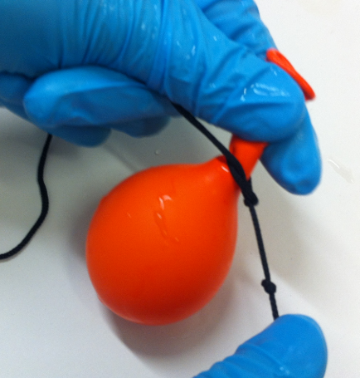

PRACTISE THE REST OF THIS PROCEDURE WITH A BALLOON FILLED WITH AIR BEFORE USING YOUR CARBON DIOXIDE

1. Fill a water bowl and invert a 100 mL measuring cylinder. Now bubble the gas into the measuring cylinder. You may find it easiest to attach a piece of tubing to the end of the balloon.

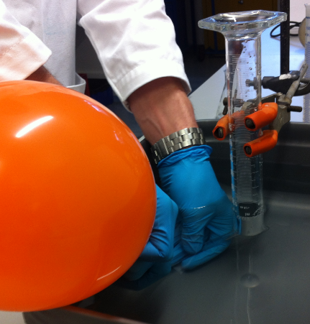

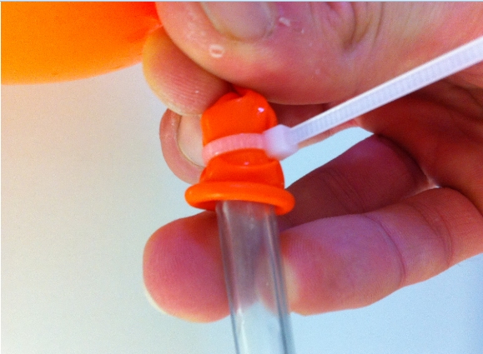

1. Record the amount of gas that was bubbled though, this will be used to calculate the percentage yield of the reaction.
2. Transfer the gas from the measuring cylinder into an inverted conical flask. This is performed underwater. Now stopper the inverted conical flask with a subaseal. Check that it is air tight by seeing if any bubbles escape when held under water.

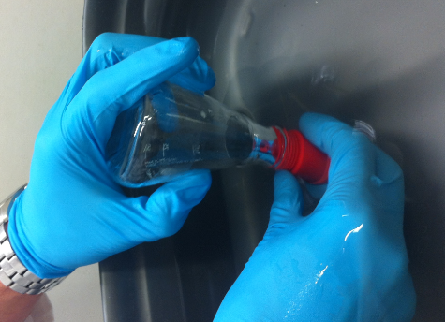

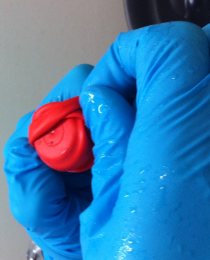

1. Stopper another conical flask with a subaseal that just contains air.
2. Your teacher will either supply you with a heat lamp or a hot water bath (on a hotplate) as a source of IR radiation. Subject both flasks to 5 minutes of the same IR radiation (the hot water bath should be at approximately 80oC). Ensure that conditions are the same.
3. Remove the flasks and force an electronic thermometer through the subaseal (your teacher will show you how to do this). Measure both the maximum temperature and how the gases retain their heat with time. Comment on the results. Note the subaseal will close up when the thermometer is removed.

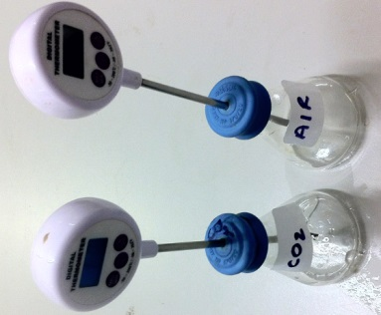

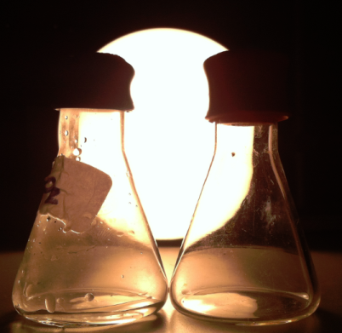

1. The carbon dioxide gas will extinguish a lit splint.

Additional Questions:

* What is the percentage yield of the reaction of the acid + carbonate?
* How could the percentage yield be improved? Give three ways.
* Suggest how the same amount of water vapour in the CO2 flask affects the results.
* Will nitrogen, oxygen or argon appear in the IR spectrum of air? Explain your answer.
* Describe a potential method to store CO2 emissions, without releasing them into the atmosphere.

*Finish all Questions for Homework*