**As-Level Chemistry, OCR Examination Board.**

**Unit: 3.2 Section: F322Chains Energy and Resources**

**St Patrick’s Day Double Lesson Plan (2 Hours) . Week of 17th March**

*Green Chemistry and Greenhouse gases.*

**Double Lesson Overview:** (*Simplifications may be made to reduce the experimental time)*

**Lesson 1 (Part A):** The students will perform simple titrations to work out the molarity of a ‘green’ renewable acid (lemon juice/ vinegar) and find the percentage by mass of sodium carbonate in washing soda. They will use their results to design a reaction producing a maximum of 150 mL of CO2.

**Lesson 2 (Part A & Part B):** Students will perform the reaction to produce the carbon dioxide, which is collected underwater. They will then show that it acts as a greenhouse gas by subjecting it to IR radiation. A comparison will be made with normal air subjected to the same conditions.

**Lesson 1: Reaction calculations allied to Green Chemistry (From OCR Course Specification):**

* Titration Calculations [1.1.3 (k)]
* Reaction Calculations and retro analysis of mole ratios needed for a reaction, starting from a gas [1.1.2 (f),(g), (h)]

The objective is to produce carbon dioxide for use in Lesson 2

Sodium Carbonate

**Carbon Dioxide** + Water + sodium Salt

Citric Acid/

Acetic Acid

+

Lemon Juice (citric acid) or distilled Vinegar (acetic acid) are a source of ‘Green Acid’. Lemon juice is naturally sourced and vinegar comes from the oxidation of natural alcohol from corn or fruit (apples)

**Experimental Procedure (Lesson 1) – This should be carried out in pairs:**

* Titrate the vinegar/ lemon juice against 0.1 M NaOH to work out its concentration.

**Acetic Acid Example (Be sure to use distilled vinegar):**

2 mL vinegar in 25 mL distilled water required 23.2 mL NaOH to reach phenolphthalein end point.

NaOH + CH3COOH CH3COONa + H2O

Therefore: $n\left({CH}_{3}COOH\right)=0.00232 mol$

Therefore: $c\left({CH}_{3}COOH\right)=\frac{n×1000}{v}=1.16moldm^{-3}$

There is an acidity percentage on the label of the vinegar label. For the above bottle it 5%. This can be used by the teacher to check the accuracy of the calculation:

RFM(CH3COOH) = 60.05 gmol-1

Vinegar bottle volume: 568 mL,

If bottle was pure acetic acid then it would contain 9.9317 moles of acetic acid,

From calculation above there are 0.00232 mol/ 2mL,

Therefore from the calculation there are 0.6588 moles in the bottle,

$\frac{0.6588}{9.9317}×100\%=6.63\%$ acidity in the bottle from our titration calculation, *c.f. 5%.*

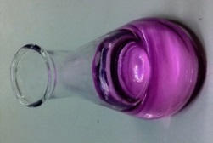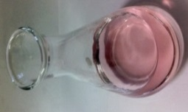

**Note:** the dilution of the vinegar/ lemon juice does not affect the calculation however it does affect the intensity of the colour change of the phenolphthalein end point. The left hand image is for high water dilution and the right hand for low dilution.

**Lemon Juice Example:**

2 mL of lemon juice in 25 mL distilled water took 28.4 mL of 0.1 M NaOH to reach the phenolphthalein end point.

3NaOH + C6H8O7 C6H5O7Na3 + 3H2O

Therefore: $n\left(C_{6}H_{8}O_{7}\right)=0.00284 mol$

Therefore: $c\left(C_{6}H_{8}O_{7}\right)=\frac{n×1000}{v}=1.42 moldm^{-3}$

It is not possible to check the molarity of citric acid as the acid content varies widely between lemons; consequently there is no indication of the acidity content on the lemon juice bottle.

We assume that citric acid acts as a triprotic acid forming sodium tricitrate. In reality the species is in equilibrium. Similarly we assume that the acidity is only due to citric acid and that other natural acids are negligible e.g. ascorbic acid

**Note:** The stoichiometry of the above citric acid example may act as a source of confusion for the students. Remember the amount of NaOH needed for neutralisation equals the number of moles of acid. The stoichiometry is ignored!

* Either synthetic sodium carbonate or washing soda can be used as the carbonate.

Washing soda is not pure sodium carbonate, and its percentage by mass can be worked out by titration. Students can also practise a reverse titration where the phenolphthalein colour change is from pink to colourless.

**Washing Soda Example:**

0.200g of washing soda crystals in 25 mL of distilled water took 7.2 mL of 0.1 M HCl to reach the phenolphthalein end point.

Na2CO3 + 2HCl 2NaCl + H2O + CO2

Therefore: RFM (Na2CO3) = 105.98 gmol-1

Therefore: $mass\left({Na}_{2}{CO}_{3}\right)=0.00072 ×105.98=0.0763g$

$\frac{0.0763}{0.200}×100\%=38\%$ by mass.

It is important to note that washing soda contains pure sodium carbonate, however baking soda contains ‘sodium carbonates’, this includes sodium hydrogen carbonate and sodium sesquicarbonate. Be sure to check the packet to avoid confusion and lower the accuracy of the calculation.

The advantage of using washing soda over sodium carbonate is that it is cheap and an available supermarket commodity.

**Symbol Equations:**

1. Na2CO3 + 2CH3COOH 2CH3COONa + H2O + **CO2**

**Working Out Reactant Quantities**

1. 3Na2CO3 + 2C6H8O7 2C6H5O7Na3 + 3H2O + **3CO2**

The students need to design the experiment with the aim of producing e.g. 150 mL of CO2 for the second part of the experiment; accordingly they have to work out the mass of washing soda/ sodium carbonate and the volume of lemon juice/ vinegar that will need to be reacted together. The stoichiometry in the above equations needs to be carefully accounted for. Washing soda + lemon juice is the most complex combination and sodium carbonate + vinegar is the simplest. The teacher should decide based upon the aptitude of the class.

**Retro analysis to produce 150 mL assuming 100 % yield of reactions (1) and (2):**

$n\left({CO}_{2}\right)=\frac{150}{24000}=0.00625 mol$ where 1 mole of gas occupies 24 dm3 under standard conditions.

Now use the stoichiometry from the above symbol equations to work out mole ratios of Na2CO3, and CH3COOH/ C6H8O7.

1. **0.00625** mol of Na2CO3 and **0.0125** mol of CH3COOH needed
2. **0.00625** mol of Na2CO3 and **0.004167** mol of C6H8O7

Now work out the volume of vinegar/ lemon juice and masses of sodium carbonate/ washing soda required from your previous calculations.

$$v\left(vinegar\right)= \frac{0.0125(1000)}{1.16}=10.774{ cm}^{3}$$

$$v\left(lemon juice\right)= \frac{0.004167(1000)}{1.42}=2.935{ cm}^{3}$$

$$m\left({{Na}_{2}CO}_{3}\right)= 0.00625×106 =0.6625 g$$

$$m\left(washing soda\right)=\frac{(0.00625×106) }{0.38}=1.743 g$$

**Part B: Greenhouse Gases responsible for the Greenhouse Effect (From Course Specification)**

[2.4.1 parts (a), (b), (c)]:

* Visual description of CO2 as a greenhouse gas (Appreciation that the experiment could be conducted with CH4 and H2O
* Visual Explanation of a greenhouse gas
* IR Spectroscopy: the carbonyl peak (2.2.3 Modern Analytical Techniques)
* Percentage Yield: [2.1.1 (p) this is an example of “a process that has a high atom economy and a low percentage yield”].
* Atom Economy: [2.4.2 Green Chemistry (a), (ii)].

**Experimental Procedure (Lesson 2) – This should be carried out in pairs:**

The relevant quantities of the above reagents need to be measured out as accurately as possible.

* Place the carbonate in a small vial that leaves as little air space as possible at the top.
* Carefully pour the quantity of acid into a balloon. The best way to do this is to slightly inflate the balloon and fix it over the top of the measuring cylinder. Carefully squeeze out the air in the balloon and tie the top with a piece of string.
* Affix the balloon on top of the small vial and fasten in place with a rubber band (cable tie used in photo).
* Untie the string and allow the reaction to proceed. Carefully shake the reaction mixture to ensure all the reagents have reacted
* Now carefully bubble the carbon dioxide into an inverted 100 mL measuring cylinder(s) (plastic tubing shown in photo but this isn’t necessary) and calculate the percentage yield of the reaction (do not fill a measuring cylinder fuller than 100 mL with CO2 as it will not be possible to measure the volume.)

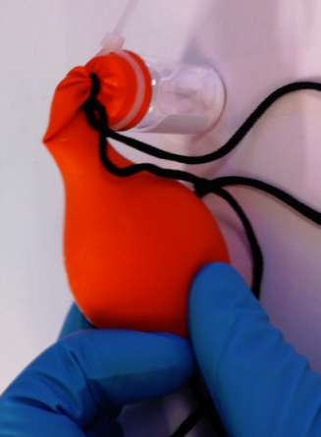

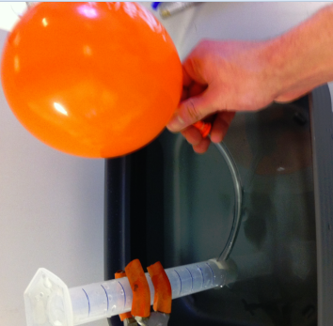

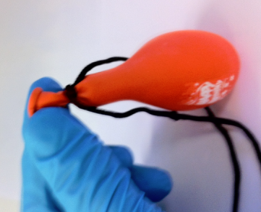

The aim of this part of the practical is to show that carbon dioxide acts as a greenhouse gas:

* Fill a conical flask underwater with the carbon dioxide in the measuring cylinder(s), depending on the percentage yield of the above reaction you will either use a 50 mL or a 100 mL conical flask.
* Under water place a subaseal on top of the flask and then invert the flask (whilst keeping it under water) and check to see that no carbon dioxide escapes. This step is very important.
* Place a subaseal on a conical flask filled with air.

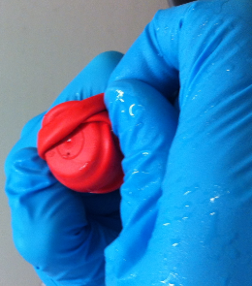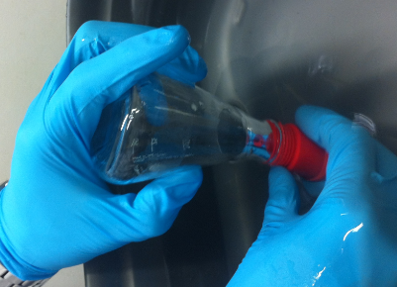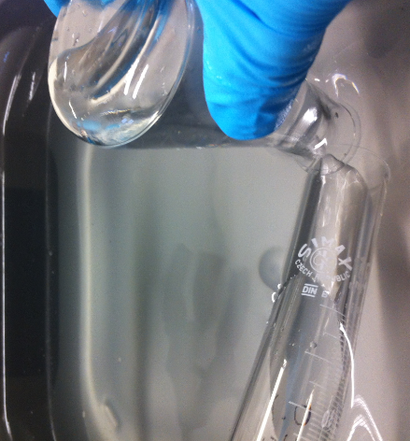

It is now possible to show that carbon dioxide is a greenhouse gas in two ways: either with (1) a heat lamp or with (2) a hot water bath. Using a hot water bath may be the most convenient method for schools.

1. Place the 2 conical flask at a fixed distance, close to the heat source and expose for approximately 5 minutes. Turn of the heat lamp and remove the 2 flasks. Force an electronic thermometer through the subaseal and measure both the temperature maximum and how the gases retain the heat over the next 5/ 10 minutes. Take readings every 15 seconds. The thermometer must not be placed into the conical flask before the lamp is switched off.
2. Clamp the 2 conical flasks in a hot water bath at approximately 80 oC and allow them to heat up for 5 mins. Perform the same procedure as above, measuring the temperatures and the retention of heat.

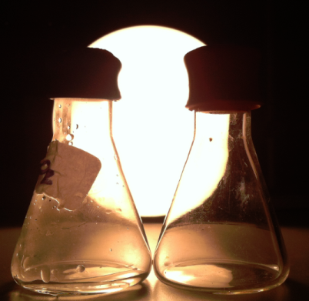

(1)

(2)

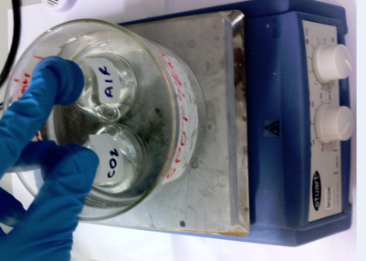

It is very apparent that the carbon dioxide absorbs and retains the heat better than air. A temperature difference of above 10 oC is recorded for both set ups.

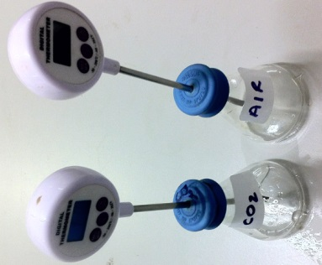

* Students should finally check that the gas is in fact carbon dioxide by removing the seal and dipping a lit splint into both flasks. The carbon dioxide will extinguish the flame.

**Questions for the students:**

They are expected to work out the relevant concentrations, volumes and masses of reagents required for the reaction during lesson time.

Please see the student resource; the answer sheet is also attached.

**Extension question:**

Why does a greenhouse gas absorb IR radiation?

* (ANSWER) In order to absorb IR radiation there needs to be a change of dipole moment in the molecule, this is not the case for diatomic molecules of oxygen, nitrogen and monoatomic argon. These gases make up the majority of the Earth’s atmosphere and therefore do not contribute to global warming.

**Additional Information:**

Phenolphthalein indicator can be made by adding 0.01g of solid to 10 mL of distilled water. This is then added to ethanol (96 %). This volume should be plenty for a large sized class. See risk assessment for hazard data on phenolphthalein.

Attached is a spectrum of carbon dioxide and air. It is unusual and will be unfamiliar to the students. It should be used at the teacher’s digression. It displays vibrational structure and peaks corresponding to vibrational modes which are not present in a carbonyl e.g. ketone or aldehyde.

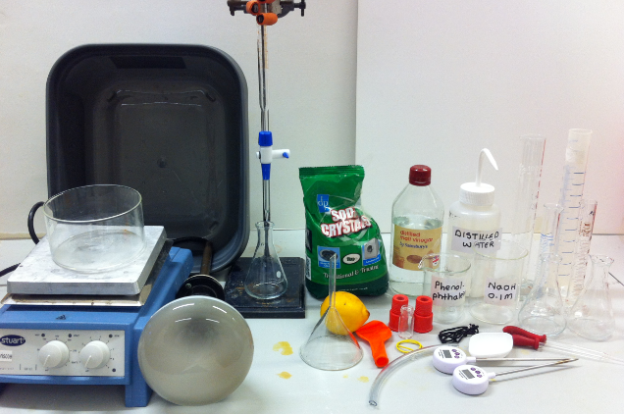**Equipment per pair:**

Conical Flask x 2

10 mL measuring cylinder

Balloon (+ spare in case it breaks)

Water bath

Hot plate

Measuring cylinder x 2

Rubber band/ cable tie

String

Sample vial

*Enlarge this picture for a better view.*

**Subaseal x2** (do not use bung as gas might escape,

A subaseal is safer and easier to insert thermometer)

Electronic thermometer x 2 (with point on end to pierce bung)

**Shopping List for class of 20 pupils (10 pairs):**

|  |  |  |
| --- | --- | --- |
| Item | Number | Cost (according to Sainsburys) |
| Distilled vinegar | 5 x 568 mL bottles | 5 x 50p |
| Lemon Juice | 6 x 250 mL bottles | 6 x 50p |
| Party balloons | 2 x 10 pack | 2 x 99p |
| Washing soda | 1 x 500g packet | £1.99 |
| Sodium carbonate | From Lab | - |
| String | - | - |
| Rubber bands | 1 x pack of 40 | 69p |

**Total:** Approximately £10.

If you have any additional questions about the experiment please contact Will Joyce. ([william.joyce11@imperial.ac.uk](mailto:william.joyce11@imperial.ac.uk)

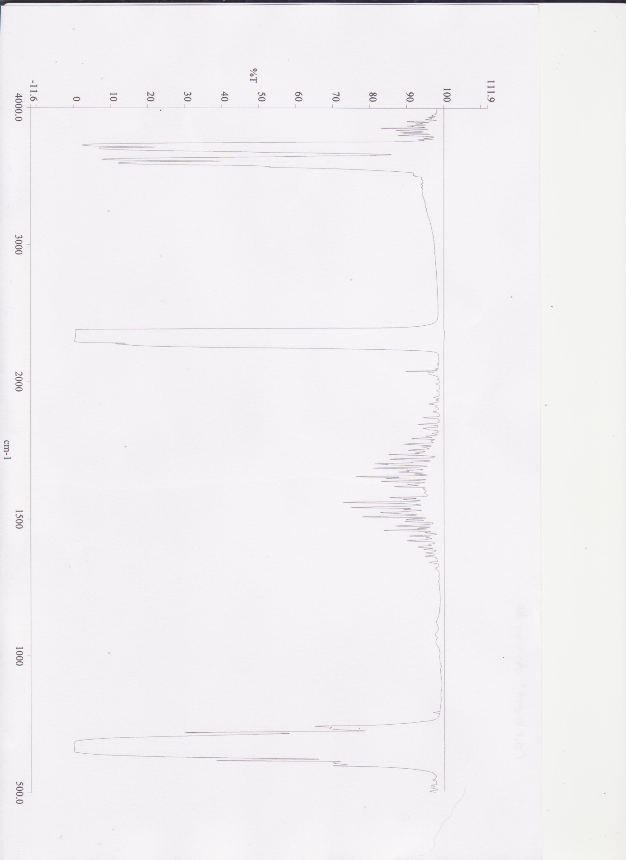

***Note:*** *The OCR Exam data sheet states that the carbonyl absorption lines between 1640 - 1750 cm-1. The above spectrum does not display the ‘traditional’ sharp carbonyl peak as in e.g. ethanol rather it shows vibrational structure in this range. There are also other peaks which the students will not be able to understand due to different vibrational modes. The spectrum has been included to illustrate the point that atmosphere Carbon dioxide can be monitored from IR spectroscopy; this pure spectrum should be compared with the spectrum of ‘air’ below.*

**IR Spectrum of Carbon Dioxide Gas**

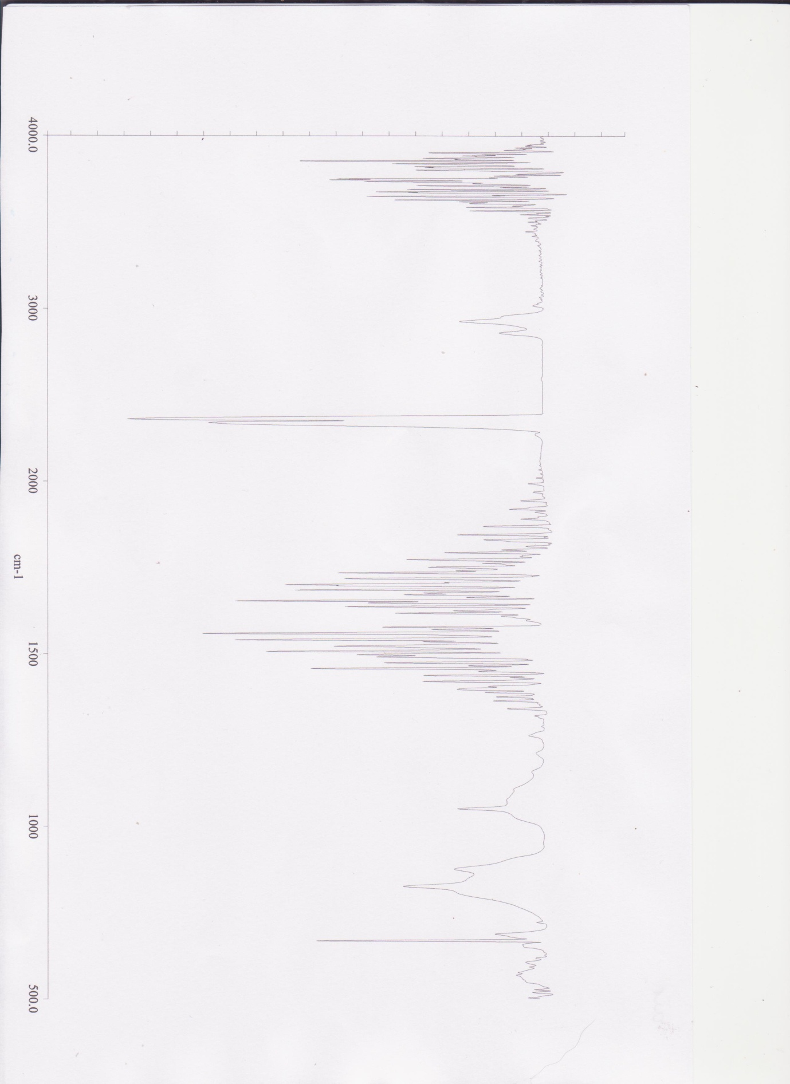

**IR Spectrum of Air**

***Note:*** *It is easy to see the peaks corresponding to carbon dioxide. Other absorptions will correspond to water vapour and methane. Perhaps the students will be able to explain why there are no peaks corresponding to nitrogen, oxygen and argon, all of which are present in the atmosphere in significantly higher concentrations than the above.*

***Note:*** *These spectra should be used with teacher digression. The absorptions should not be analysed and they are only included to illustrate that atmospheric carbon dioxide concentration can be measured by IR spectroscopy.*