No. | Form of vibration | Frequency | Intensity | Symmetry,  D_{3H} point group
1 | 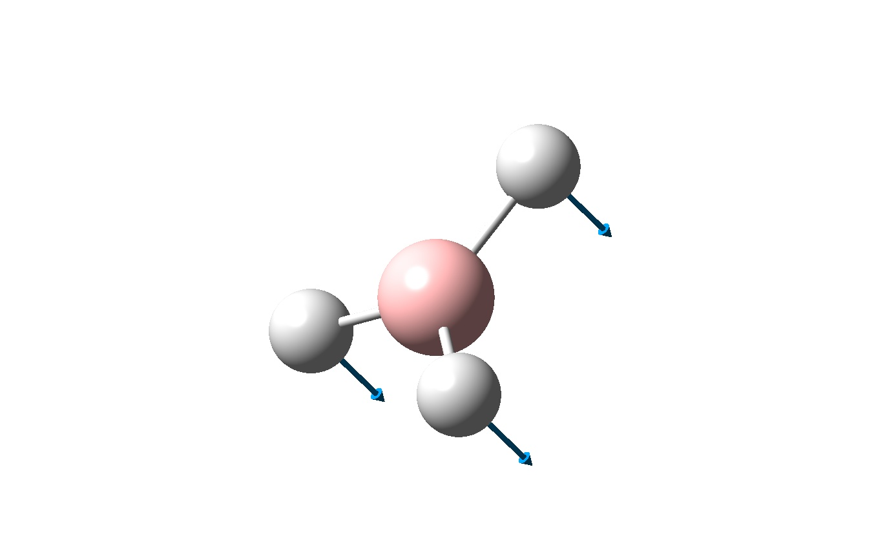  H atoms move up and down, together, the B atom remains stationary | 1145.71 | 92.699 | A₂’’
2 | 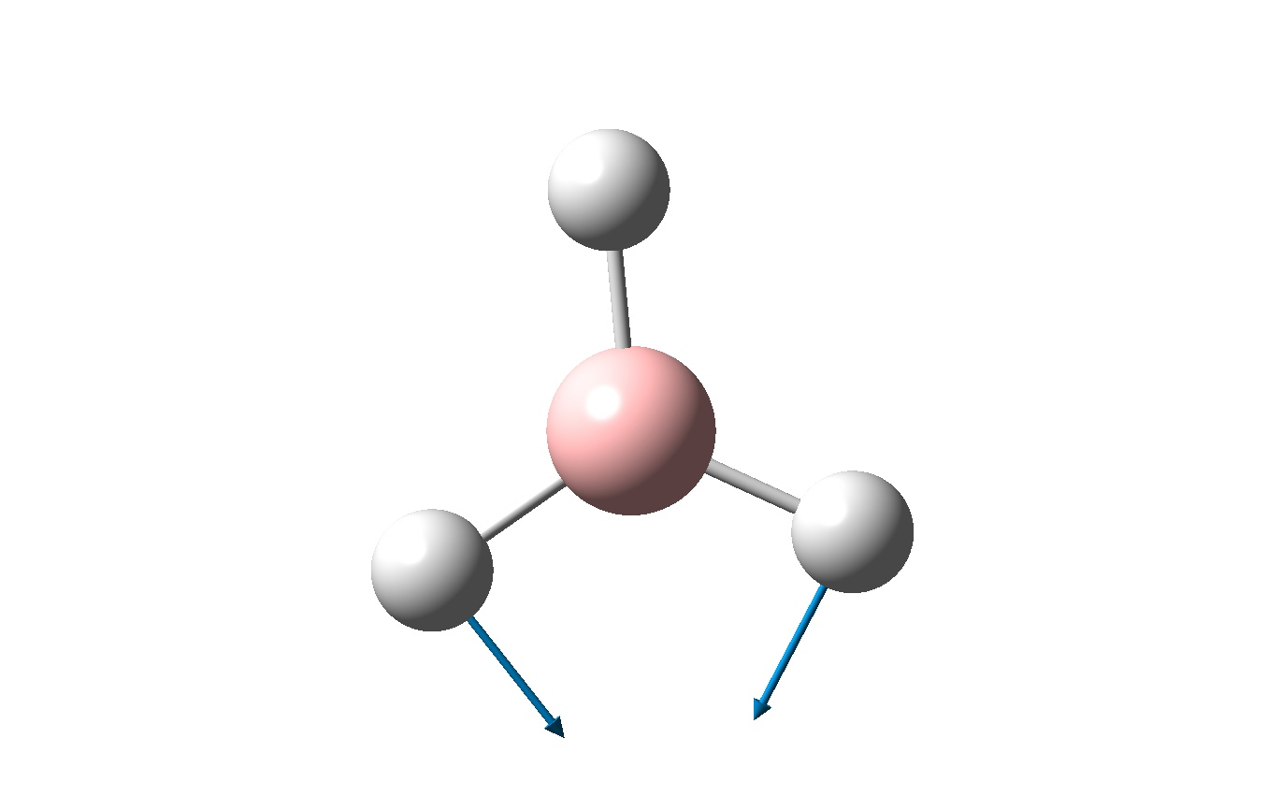  Two H atoms move towards each other in a scissoring motion. | 1204.66 | 12.379 | E’
3 | 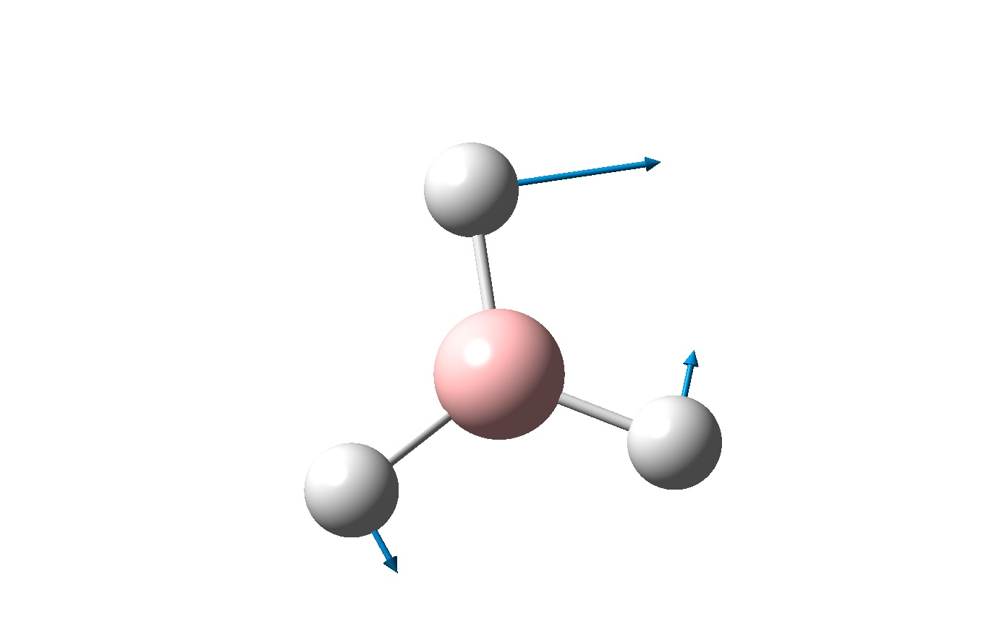  One H atom moves alot sideways in one direction, the other two move a little in the opposite direction. | 1204.66 | 12.381 | E’
4 | 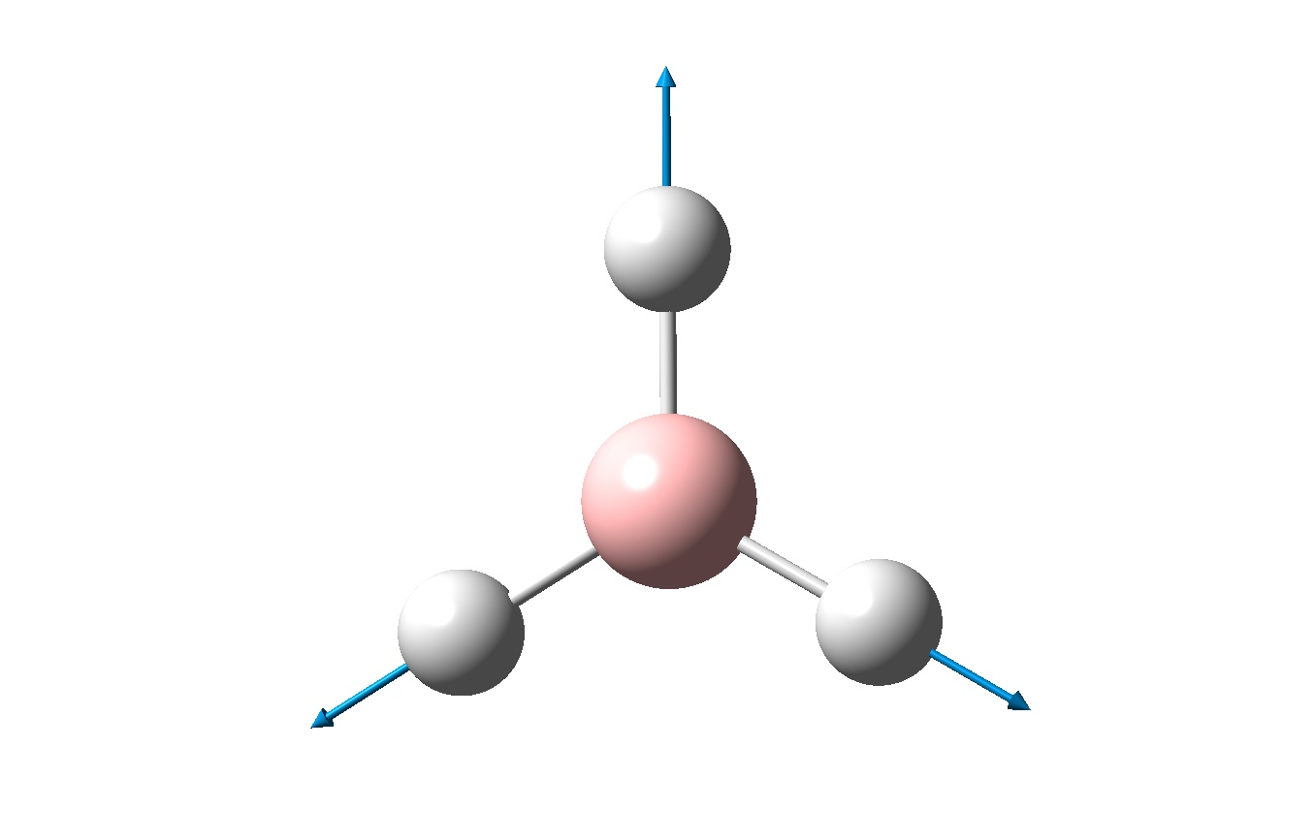  All three H atoms move in and out away from the stationary B atom. | 2592.79 | 0 | Totally symmetric,  A’₁
5 | 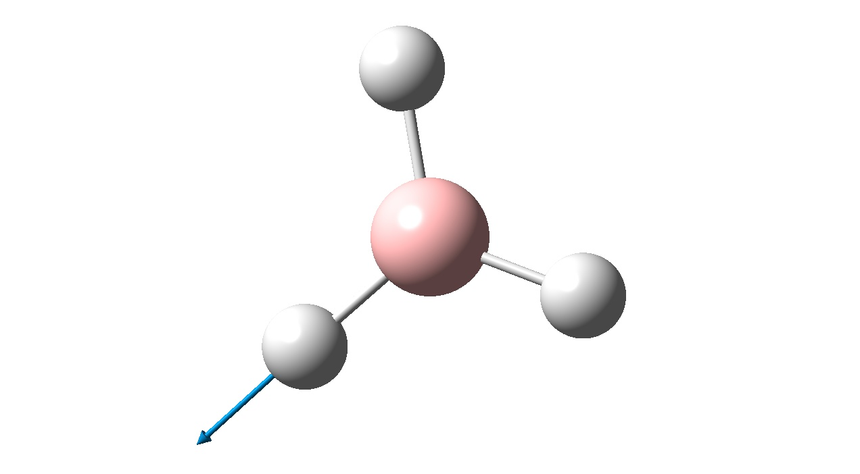  One H atom moves in and out, all other atoms remain stationary. | 2731.31 | 103.837 | E’
6 | 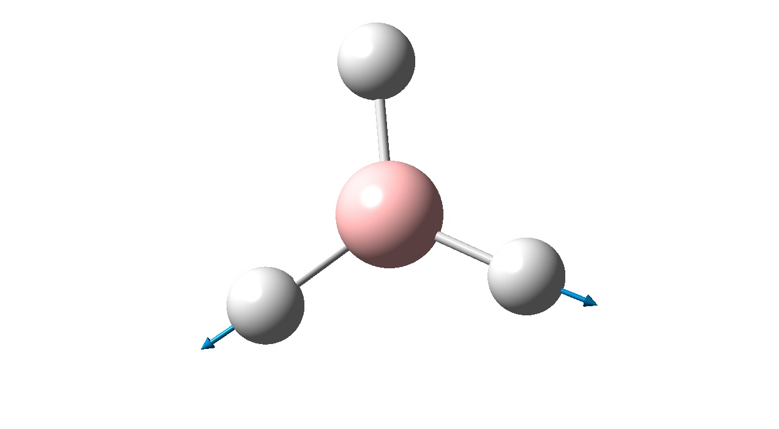  Two H atoms move in and out, the other atoms remain stationary. | 2731.31 | 103.85 | E’

