Molecular Dynamics Simulation of condensed phases

Simulation of water and water solutions using DL_POLY 2.0

Dr. Fernando Bresme
Department of Chemistry
Imperial College London
Computer Simulations of Condensed Phases using DL_POLY 2.0

Molecular Dynamics simulations of water and water solutions

1. Introduction

Molecular Dynamics computer simulation is a theoretical approach to investigate the structure and dynamics of atoms, molecules and molecular assemblies using microscopic information based on intermolecular potentials. In this laboratory you will investigate the properties of condensed phases using a general purpose molecular dynamics code called DL_POLY. DL_POLY is a parallel simulation package developed at Daresbury Laboratory. Most of the documentation relevant to this package can be found in:

http://www.cse.clrc.ac.uk/msi/software/DL_POLY/MANUALS/USRMAN2/USRMAN.html

You will find this web page very useful. It contains valuable information on the theoretical basis and implementation of the Molecular Dynamics algorithms, and also practical information on the DL_POLY error messages.

In this laboratory you will focus on molecular dynamics simulations of water and water solutions. Water is the most abundant compound on the surface of Earth. It is the most important solvent, providing the environment where many physical processes occur, from protein folding to electron transfer processes at interfaces, and mineral dissolution and corrosion processes. Water exhibits an anomalous behavior in almost any property one can measure (see for instance Ref.); high dielectric constant, high heat capacity, high melting, boiling and critical temperatures. Also, the thermal conductivity exhibits an anomalous decrease with temperature, the solid phase diagram contains a very large number of polymorphs, it exhibits a density maximum at 4 ºC, … Taking into account this complex behaviour it is clear that the simulation of water is a non trivial exercise.

There are many different types of water models. Here you will be investigating the properties of the water SPC/E model, which is a semi empirical model that accurately reproduces the properties of liquid water at ambient temperature. This laboratory encompasses a number of investigations: the structure and thermodynamics of water at normal, high pressure and near critical conditions, the phase coexistence properties of water, the density maximum of water and the structure of water solutions…. but, before we do all this we need to know something else about DL_POLY.

2. Molecular Dynamics simulations using DL_POLY

To run a simulation with DL_POLY you need the executable, “DLPOLY.X” and three files; “CONTROL”, “CONFIG” and “FIELD”. The executable and other programs and files that you will need to solve the exercises will be provided at the beginning of the lab.

The “CONTROL” file defines the simulation conditions. “CONTROL” makes use of keywords to define the run temperature, ensemble, timestep… etc. An example “CONTROL” file is given below:

Title Record: Example CONTROL file for DL_POLY

# define the state point
temperature 300.0

# simulation length and equilibration
steps 2000
equilibration steps 1000
scale every 5 steps
timestep 0.0005 ps

# specify cutoffs
cutoff 7.6 angstrom
rvdw cutoff 7.6 angstrom
delr 0.5 angstrom

# forces options
Ewald precision 1.E-6

# ensemble options
ensemble nve (default option)

# statistics controls
stats every 2000 steps
stack 100 deep

# trajectory dumping controls
trajectory nstraj 1 istraj 50 keytrj 0

# print controller
print every 100 steps

# rdf options
rdf sampling every 10 steps
print rdf

# job time and permitted wind-up time
job time 21000 seconds
close time 200 seconds

finish

The example above corresponds to a simulation in the microcanonical ensemble (NVE). The temperature is set to 300 K, and the timestep, used to integrate the equations of motion, is 0.0005 ps, The forces between particles are cut-off at 7.6 angstroms. This means that the forces are set to zero beyond this distance. In this laboratory you will be using the Ewald method (Ewald precision 1e-6), to compute the coulombic interactions arising from the partial charges in the SPC/E model. Reference Error: Reference source not found explains in detail the Ewald method. Note that in the CONTROL file there are lines starting with the “#” symbol. This symbol is used to write a comment.
The CONFIG file contains the dimensions of the unit cell, defines the periodic boundary conditions, atomic labels and atomic coordinates. This file contains the positions of the atoms we want to simulate. An example of a CONFIG file is given below.

IceI structure 6x6x6 unit cells with proton disorder
2 3
26.988000000000000 0.000000000000000 0.000000000000000
-13.494000000000000 23.372293600000000 0.000000000000000
0.000000000000000 0.000000000000000 44.028000000000000
OW 1
-2.505228382 -1.484234330 -7.274585343
0.5446573999 -1.872177437 -0.7702718106
3515.939287 13070.74357 4432.030587
HW 2
-1.622622646 -1.972916834 -7.340573742
1.507099154 -1.577400769 4.328786484
7455.527553 -4806.880540 -1255.814536
HW 3
-3.258494716 -2.125627191 -7.491549620
2.413871957 -4.336956694 2.951142896
-7896.278327 -8318.045939 -2379.766752
OW 4
0.9720599243E-01 -2.503798635 -3.732081894
1.787340483 -1.021777575 0.5473436377
9226.455153 9445.662860 5365.202509

etc.

For each atom the first row represents the coordinates in angstrom, and the second and third rows the velocities and the forces respectively. The CONFIG file for a given system (water for instance) can be generated using a java applet that is part of the DL_POLY code. We will see an example later on.
Finally, the FIELD file contains the force field information, i.e., it defines the intermolecular interactions.
Lattice file generated by FILE_MAKER utility
UNITS kJ
MOLECULES 1
spce water
NUMMOLS 256
ATOMS 3
OW 15.9994000 -0.84760000
HW 1.00797000 0.42380000
HW 1.00797000 0.42380000
CONSTRAINTS 3
1 2 1.000000
1 3 1.000000
2 3 1.632880
FINISH
VDW 3
OW OW lj 0.65020000 3.16600000 0.00000000
OW HW lj 0.00000000 1.00000000 0.00000000
HW HW lj 0.00000000 1.00000000 0.00000000
CLOSE

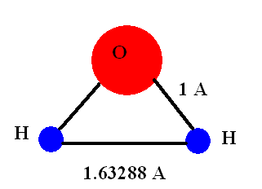
The example above defines the water SPC/E model. We consider in this case 256 molecules. Each molecule is modelled as a rigid triangular frame (see figure on the right). This can be done using the CONSTRAINTS command. The SPC/E model has three rigid bonds; two OH = 1 Ǻ, and one HH = 1.632880 Ǻ, which corresponds to an HOH angle of 109⁰. The force field also defines the atomic mass of the atoms, oxygen and hydrogen, and the partial charges on each atom. Finally the VDW 3 command in the FIELD file defines the intermolecular interactions. These are modelled using a Lennard-Jones potential (key “lj” in the FIELD file):

$U(r)=4ε\left[{\left(\frac{σ}{r}\right)}^{\text{12}}−{\left(\frac{σ}{r}\right)}^{6}\right]$, where ε is the potential depth and σ the atom diameter (in Ǻ).
The units for the potential depth, ε, are defined in the top of the FIELD file, “UNITS kJ”, meaning kJ/mol. In the SPC/E model the van der Waals interactions only involve oxygen pairs, the oxygen-hydrogen and hydrogen-hydrogen interactions are set to zero. Oxygen-hydrogen and hydrogen-hydrogen interact between them through coulombic interactions only.

Once the CONTROL, CONFIG and FIELD files have been define, DL_POLY can be executed using the command ./DLPOLY.X

3. Generating CONTROL, CONFIG, and FIELD files using the Java Graphical User Interface

The Java Graphical User interface (GUI) provides an easy way to generate the files needed to run a molecular dynamics simulation. To start the GUI write ./gui (in the execute directory) in the Linux command line. Two windows will appear, “Monitor” and “DL_POLY GUI” (see figure below).

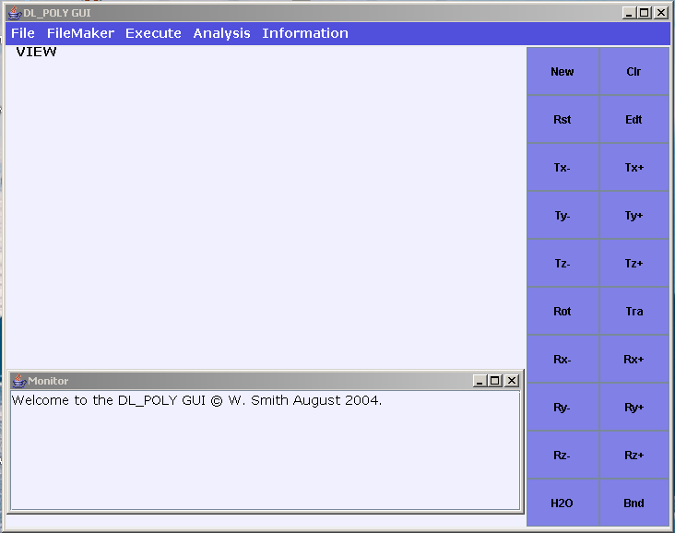

Let us generate a configuration of liquid water. Under the “FileMaker” option select “CONFIG” and then select “Lattice”. A new window will appear. Set the A, B and C vectors to: A=(22,0,0), B=(0,22,0), C=(0,0,22) Ǻ. Click “Make”. A cubic box of length 22 Ǻ will be created. Now we will fill the box with a pre-equilibrated configuration of water. Under the “FileMaker” option, select “Tools” and then “Add Water”. A new window will appear. Set the “Min water-water distance” to 1.35 Ǻ, and click “Make”. A new configuration should appear (see below).

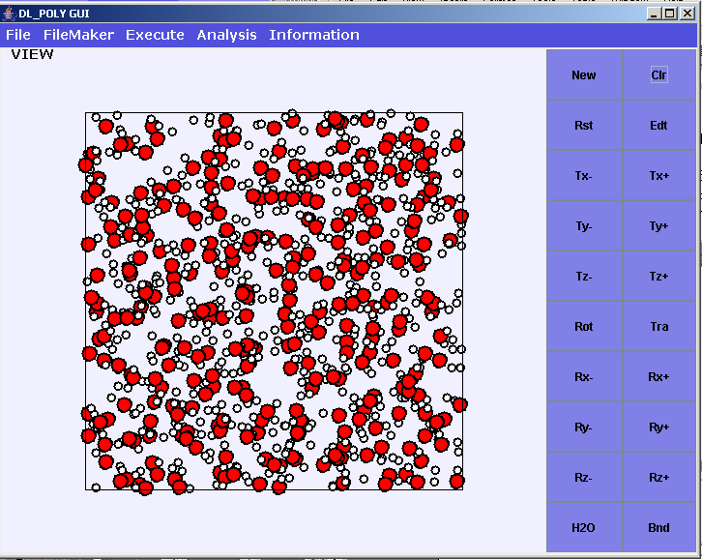

The GUI program will also generate a file called “CFGH20.0”. This is the CONFIG file we will use later on in our simulations of water.

Let us generate now templates for the “CONTROL” and “FIELD” files using the “FileMaker” option. Select “FIELD” and “BLANK” to generate the FIELD file. This will generate a file called FLDBLK.0 that we will edit later to define the SPC/E water model. To create the CONTROL file select “CONTROL” under the “FileMaker” option. A new window will appear. Set the “time step” to 0.002 ps, the “Cutoff” to 9 Ǻ, the “Verlet shell width” to 1 Ǻ, the “VDW cut off” (van der waals cutoff) to 9 Ǻ. Select the “EWALD” method to compute the columbic forces. Click “Make”. The GUI will create the file “CNTROL.0”, which we will be using to run our first simulation of water. Before you do this you will need to rename the files CFGH20.0, FLDBLK.0 and CNTROL.0, to CONTROL, CONFIG and FIELD.

Example: Using the files generated above we are going to simulate water at 298 K in the microcanonical ensemble (NVE). First, edit your CONTROL file so that you have the same definitions given in the example below. Delete any line not appearing in the example.

CONTROL file generated by DL_POLY/java utility
temperature 298.00
ensemble nve
steps 500
equilibration 500
scale 1
print 10
stack 100
stats 10
timestep 0.0020
cutoff 9.0000
delr width 1.0000
rvdw cutoff 9.0000
ewald precision 1.0E-6
shake tolerance 1.0E-6
job time 100000.00
close time 10.000
finish

Edit your FIELD file and define the partial charges, bond distances and pair potentials of the water SPC/E model. Your FIELD file should look like:

Lattice file generated by FILE_MAKER utility
UNITS kJ
MOLECULES 1
spce water
NUMMOLS 256
ATOMS 3
OW 15.9994000 -0.84760000
HW 1.00797000 0.42380000
HW 1.00797000 0.42380000
CONSTRAINTS 3
1 2 1.000000
1 3 1.000000
2 3 1.632880
FINISH
VDW 3
OW OW lj 0.65020000 3.16600000 0.00000000
OW HW lj 0.00000000 1.00000000 0.00000000
HW HW lj 0.00000000 1.00000000 0.00000000
CLOSE

Check that the definitions in your FIELD file are consistent with the SPC/E model parameters published by Berendsen et alError: Reference source not found.

Once you have got all your files, execute ./DLPOLY.X

NOTE: The input file, FIELD, is read with a fixed format. This means that the variables defining the potential, charge etc, have to be separated by a pre-defined number of spaces. Example:

The following line: “OW OW lj 0.65020000 3.16600000 0.00000000” is correct,
whereas “OW OW lj 0.65020000 3.16600000 0.00000000” will not work. If you are getting error messages when trying to execure DLPOLY, check first whether you are using the right format in your FIELD file.

DL_POLY will generate several files:

- “OUTPUT” contains all the information regarding the thermodynamics and structural properties of the system. A typical OUTPUT file looks like:

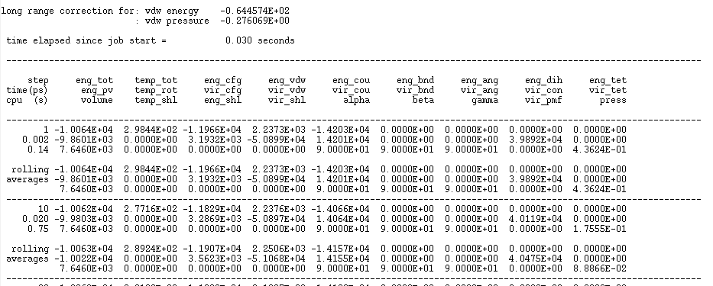
Where the labels refer to (see DL_POLY manual):
line 1
step MD step number
eng_tot total internal energy of the system
temp_tot system temperature
eng_cfg configurational energy of the system
eng_vdw configurational energy due to short-rangepotentials
eng_cou configurational energy due to electrostaticpotential
eng_bnd configurational energy due to chemical bondpotentials
eng_ang configurational energy due to valence angleand three-body potentials
eng_dih configurational energy due to dihedralinversion and four-body potentials
eng_tet configurational energy due to tethering potentials
line 2
time(ps) elapsed simulation time (ps) since the beginning of the job
eng_pv enthalpy of system
temp_rot rotational temperature
vir_cfg total configurational contribution to thevirial
vir_vdw short range potential contribution to thevirial
vir_cou electrostatic potential contribution to thevirial
vir_bnd chemical bond contribution to the virial
vir_ang angular and three body potentials contribution tothe virial
vir_con constraint bond contribution to the virial
vir_tet tethering potential contribution to the virial
line 3
cpu (s) elapsed cpu time since the beginning of the job
volume system volume
temp_shl core-shell temperature
eng_shl configurational energy due to core-shellpotentials
vir_shl core-shell potential contribution to the virial
alpha angle between and cell vectors
beta angle between and cell vectors
gamma angle between and cell vectors
vir_pmf Potential of mean force constraint contribution to the virial
press pressure

The properties in bold face are the ones we will be investigating in the present laboratory.

In addition to the OUTPUT file, DLPOLY will generate the following files:

- STATIS, which contains a summary of statistical data, and
- REVCON, which contains a sample of the final configuration.

The STATIS file can be used to analyze the simulation trajectory. The DLPOLY GUI provides an interface to do this in an easy way. Open the GUI and select “Analysis / Tools / Statistics”. A new window will appear. Now you can plot the system properties as a function of the simulation time. Select “E-TOT” and click “RUN”, to plot the variation of the total energy with time (see below).

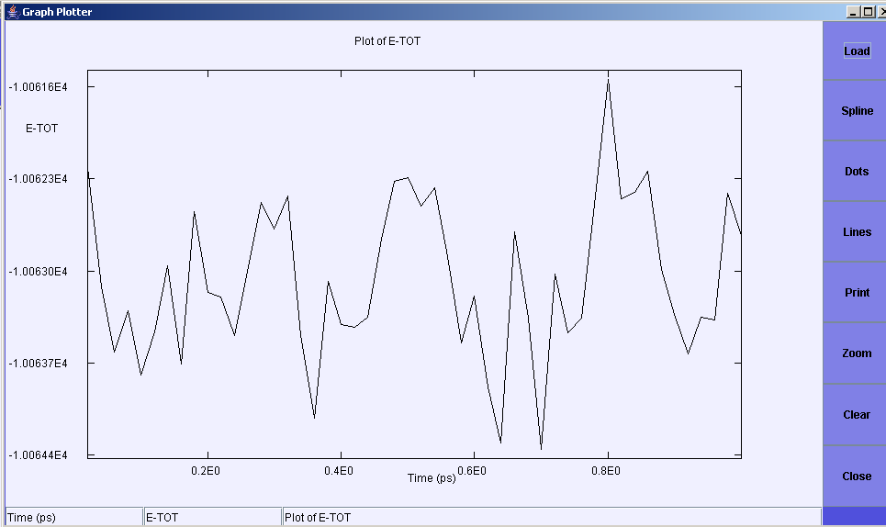

Try plotting other properties, temperature, configurational, van der Waals and coulombic energies. Note that each time you select one of these properties the GUI generates a file with the name STATS0.XY, STATS1.XY, …, which contains the data represented in the graphs.

The GUI can be used to draw the final configuration, REVCON. Just select “Analysis/ Display/ REVCON”. The configuration can be rotated, and bonds can be represented using the options appearing on the right panel of the DL_POLY GUI.

4. What time step should you use in your simulations?

One of the main variables in molecular dynamics simulations is the timestep. The timestep determines the accuracy in the numerical integration of the equations of motion. A too small time step provides good accuracy in the integration of the equations of motion. The disadvantage is that very long simulations times are needed to ensure adequate sampling of the system. A too large time step enables longer simulation times but introduces inaccuracies in the integration of the equations of motion that result in incorrect simulations. As a general rule an adequate timestep should ensure that the constraints in an ensemble, eg NVE, should be conserved, i.e., should be constant during the run. For instance, in the microcanonical ensemble (once the equilibration period has finished) the total energy should be conserved. This is a good way to see whether the timestep you are using is adequate.

In this question you are asked to investigate the effect of the timestep on the computer simulation of water using the microcanonical ensemble (NVE). Perform two simulations using the timesteps 0.002 and 0.008 picoseconds. You may consider a simulation with 500 steps as total number of steps and 250 steps for the equilibration period.

Plot the total energy as a function of time for the two simulations (you can use the GUI program to extract the energy from the STATIS files). Is 0.008 ps a reasonable choice for the simulation of SPC/E water?

Important: each time you run a simulation DL_POLY overwrites any existing STATIS, OUTPUT and REVCON files; to keep the results from previous exercises, remember to rename the files at the end of each run.

EXERCISES

In the following exercises you will be investigating the properties of water at different thermodynamic conditions, from liquid at normal conditions, to water at high pressures and near critical conditions. The thermodynamic states we will consider are indicated by solid circles in the phase diagram below (see Atkins and de Paula, Oxford University Press, 7th Edition):

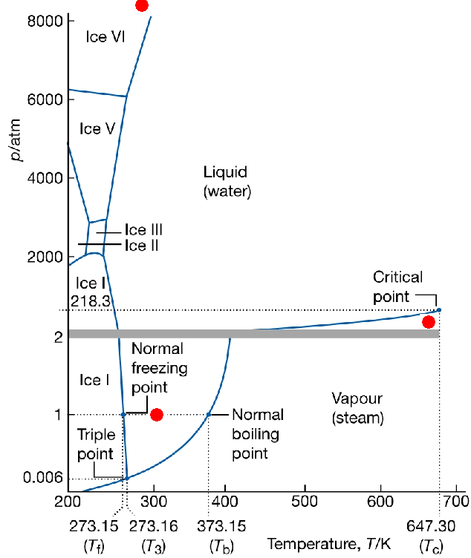

- Exercise 1: Internal energy and density of SPC/E water at ambient conditions

In the previous example we have considered simulations of water in the microcanonical ensemble (NVE). Very often it is convenient to perform the simulation in an alternative ensemble where we can set the pressure and temperature of the system. Such ensemble is called isothermal-isobaric (NpT), and is the ensemble that corresponds to experimental conditions. In this exercise you are asked to perform a molecular dynamics simulation of SPC/E water at 298 K and 1 bar pressure in the NpT ensemble. To do this eed to introduce minor changes in the CONTROL files you have used before. Just substitute

ensemble nve by ensemble npt hoover 0.1 0.1

and add to the CONTROL file : press 0.001 (pressure is in kbars)

The NpT algorithm works by coupling your system to a virtual thermostat and barostat that maintain the pressure and temperature constant. The two parameters after the ensemble definition, “0.1 ps”, are constants that specify the relaxation of the thermostat and barostat, respectively. “0.1 ps” is adequate value for the simulation of SPCE/E water.
a) Perform a simulation of SPC/E water in the NpT ensemble at T=298 K and p=1 bar. Analyse the equilibration of the system by plotting the time variation of the volume with time. To perform this simulation you should use typically 5000 steps, (2500 for equilibration).

- Calculate the configurational energy of water at normal conditions. Compare your result with the data given in references Error: Reference source not found and .

Note: DL_POLY reports the total energy for the system of N molecules. To obtain the energy per molecule you need to divide your result by the number of molecules in your simulation.

c) What is the density of the SPC/E water model at 298 K and 1 bar pressure? Compare your result with the experimental one (see reference Error: Reference source not found).

- Exercise 2: Liquid water structure and hydrogen bonding

The structure of gas, liquid or solid phases, can be analysed through the so called pair correlation function g(R). The pair correlation function quantifies the probability that a molecule will be found at a distance R from another molecule. Mathematically it is defined as:

$g(R)=\frac{ρ(R)}{ρ_{\text{id}}(R)}$,

where the numerator is the local density at a distance R from a given molecule, and the denominator is the average density of the liquid. See references Error: Reference source not found and/or for a fuller discussion.
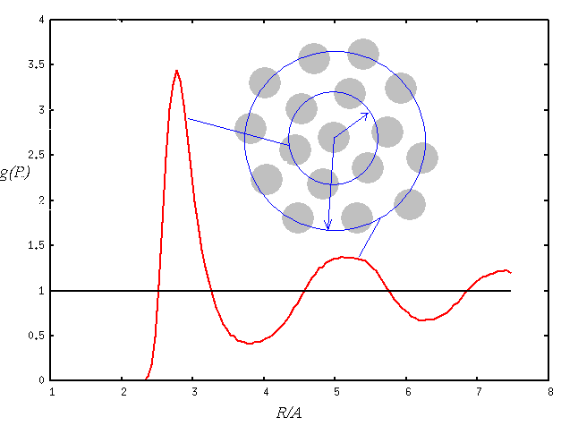
The figure on the right shows a typical radial distribution function for a dense liquid. The oscillations indicate the formation of shells of particles around a given molecule (see sketch). There are regions with a higher density than the average, g(R) > 1, which correspond with the shells of molecules surrounding a given molecule. These peaks are separated by regions where g(R) < 1. In those regions there are less molecules than we would expect from the average density. At long distances from a given molecule g converges towards the average density, g(R)→1.

Liquid water has a structure that is much more complicated than that of a simple liquid. One of the reasons of this complex structure is the existence of hydrogen bonding between molecules.

- Investigate the structure of liquid water (within the SPC/E model) at standard conditions, p=1bar and T=298 K. Since water consists of two species, oxygen and hydrogen, there are three pair correlation functions that define the water structure, g_{OH}, g_{OO} and g_{HH}. You need to compute these three functions.

To compute the pair correlation functions you need to perform your simulation (NpT ensemble) adding the following commands to the CONTROL file:

rdf 5
print rdf

This tells DLPOLY to compute the pair correlation function every fifth time step and print it at the end of the run. When the run finishes DL_POLY creates a file called “RDFDAT”.

You can analyse the pair correlation functions using the DLPOLY GUI. (See “Analysis/Structure/RDF-Plot” option). Compare your pair correlation function with the experimental pair correlation functions for water (see reference). Comment on your results.

b) Walrafen proposed many years ago a hydrogen bond structure for water consisting of a tetrahedral motif of water molecules (see Figure below).

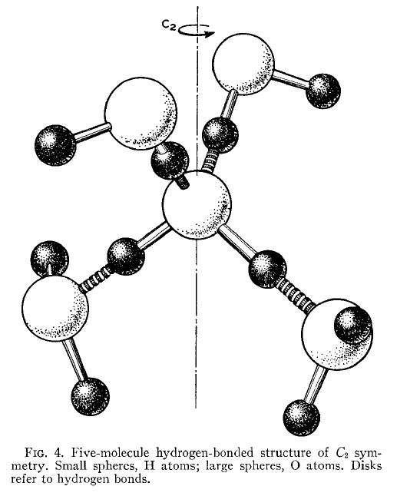
Are your pair correlation functions compatible with this structure?

To answer this question you may want to investigate whether the peaks in the radial distribution functions are consistent with the oxygen-oxygen, oxygen-hydrogen distances in the tetrahedral structure suggested by Walrafen.

Also try to compute the coordination numbers, n_{OO}, n_{OH} and n_{HH} as a function of radial distance, R. The coordination number gives the number of atoms of a given species surrounding a specific atom. The coordination number can be computed by calculating (numerically) the following integral:
$$n_{\text{αβ}}(R)=ρ_{β}\int{g(R')4πR'^{2}\text{dR}}'$$

Where α and β represent the species, O or H, and ρ_{β}, is the density of species β. If the Walrafen’s model is correct the n_{OH} coordination number at R~2.4 Ǻ should be ~2. Also the n_{OO} coordination number at 3.4 Ǻ should be ~4, compatible with the four water molecules surrounding the central one (See figure above).

You may find useful to compare your results for the coordination number with those reported in reference.

- Exercise 3 Connecting simulations to neutron diffraction experiments: The structure factor

The main quantity in a neutron diffraction experiment is the structure factor, S(k). The structure factor is the Fourier transform of the pair correlation function. It is an experimental quantity of enormous relevance since we can use it to investigate the structure of liquids. Also the structure factor at k=0, S(0) is a measurement of the compressibility of a liquid, $χ_{T}$: ${ρk}_{B}{Tχ}_{T}∝S(0)$

The structure factor and the pair correlation function are related through the following expression:

$$S_{\text{αβ}}(k)\text{\sim }x_{α}x_{β}4\text{πρ}\int{r^{2}(g_{\text{αβ}}(r)−1)\frac{\text{sin}(\text{kr})}{\text{kr}}}$$

Where the “x” symbols represent the molar fraction of atoms of species α and β, and ρ is the density of water molecules.

Your task in this exercise is to compute the oxygen-oxygen, S_{OO}(k), structure factor. To do this you need to calculate the integral in the equation above. This can be done using the DLPOLY GUI. “Analysis/Structure/S(k)” option. Note that this calculation will give you the integral only, to obtain the structure factor you need to multiply by the factors appearing in front of the integral.

Compare your structure factor with the experimental result published in Fig8-b in reference. Comment on you result.

- Exercise 4: Changing the thermodynamic state: Water at high pressure and high temperature

Water at high pressures

Pressure and temperature have a large influence on the water structure. They can induce phase transitions to solid phases for instance. The solid phase diagram of water is particularly complex, consisting of up to 8 polymorphs. The graphs below show the experimental liquid-solid phase diagram of water (left) and the recently computed phase diagram of the SPC/E model (right) (see reference Error: Reference source not found). Considering the complexity of the phase diagram, the SPC/E model does a good job predicting the solid phases of water.

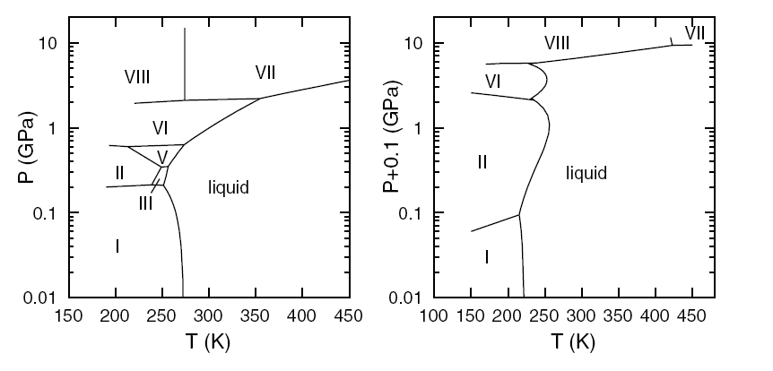

a) In this exercise we ask you to perform a simulation at a pressure, of your choice, for which the ice VIII phase of the SPC/E model is stable. You should consider constant temperature conditions T=298 K. You can monitor the equilibration of your simulation by plotting the volume of the simulation box as a function of simulation time. How many steps do you need to reach equilibration?

b) Compare the structure of the high pressure phase with that of liquid water at normal conditions. Discuss the differences. To answer this you may want to look at the pair correlation functions and at the number of hydrogen bonds (n_{oH} coordination number) of the high pressure system.

Do you see any evidence for the formation of a solid? If not could you explain why?

Water at high temperatures

From the question above you have probably found that pressure has an important effect on the water structure. Temperature has also an important effect. In the following we ask you to perform a simulation for a state point near the critical point of the SPC/E model. The estimated critical point is T_{c}=651.7 K, ρ_{c}=0.326 g/cm³, and P_{c}=189 bars, which is good agreement with the experimental critical properties of water (see for instance reference Error: Reference source not found).

Near the critical point the liquid undergoes very large fluctuations in density. This is reflected in the compressibility of the high temperature liquid which is different from that of water at normal conditions, and that diverges at the critical point.

a) Perform one simulation of liquid water at P=160 bars and T=620 K. Monitor the equilibration through the variation of the volume of the simulation cell with time. What is the equilibrium density for this thermodynamic state?

b) Analyse the structure of the high temperature system, and compare it with that of liquid water at normal conditions. Is hydrogen bonding still present at P=160 bars and T=620 K?

c) Calculate the Soo(k) structure factor of the high temperature system. The compressibility of the high temperature state is rather different from that of liquid water at normal conditions. Is this reflected in the structure factor?

- Exercise 5: Molecular Dynamics simulations of aqueous solutions.

So far we have considered pure water, but there are many processes of interest in colloidal chemistry or biochemistry that occur in aqueous solutions. The investigation of the structure of ionic solutions in water is very important to understand the role played by water in tuning ion-ion interactions. During the second year (Electrochemistry course) you came across the Debye-Huckel theory. This theory works well for highly dilute solutions, but it does not work so well for concentrated solutions. One of the main assumptions in the Debye-Huckel theory is to consider water as a structureless dielectric medium. In this exercise we investigate in detail the solvation structure of ions in water. This gives us an opportunity to asses whether theories such as the Debye-Huckel one, which neglect the molecular nature of water, are accurate.

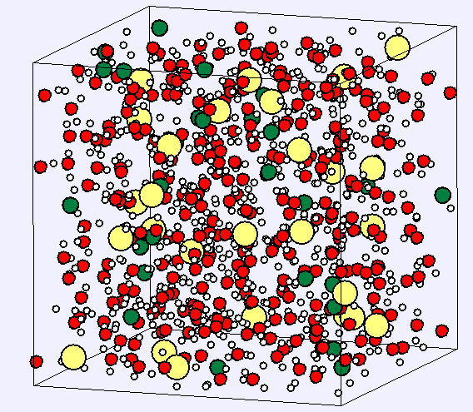
a) The first part of the exercise involves the simulation of a NaCl solution at a concentration of your choice. The concentration of the solutions should be in the interval 1 - 4 molal. We have provided you with an initial configuration of NaCl in water, with a concentration ~ 5.5 molal, and with a sample of a FIELD file that includes the water-Na⁺ and water-Cl⁻ interactions. The figure on the right shows the configuration with Cl⁻ (big spheres) and Na⁺ (small spheres)

You can use the configuration provided to generate a new configuration with a concentration of your choice. To do this just remove NaCl pairs from the CONFIG file, and modify the FIELD file accordingly.

Once you have generated your configuration perform an NpT simulation at 1 bar pressure and 298 K. Compute the pair correlation functions, and from this analyse the water structure around the ions.

Try to address the following points iyour investigation: How many water molecules are in the first coordination shell of Na⁺ and Cl⁻? (To answer this question you will need to calculate the Na⁺-O and Cl⁻-O coordination numbers). How does the salt modify the water structure with respect to the structure of bulk water? How do Na⁺-Cl⁻ ions organise in the aqueous solution? Do you find any evidence for the formation of ion pairs?

b) Perform a simulation of the aqueous solution at P=160 bars and T=620 K, i.e., near critical conditions. Analyse the Na⁺-Cl⁻ correlation functions and compare with the aqueous solution at 298 K. Can you explain the differences in the ionic structure of the two thermodynamic states?

- Exercise 6: The liquid-vapour phase coexistence diagram of SPC/E water and the density maximum

Coexistence curve

In this exercise you are asked to compute the liquid-vapour phase diagram of the SPC/E model for water. One way to approach this problem is by simulating a liquid slab of water which is surrounded by vapour. The figure below shows an example of such system. Using this configuration we can obtain the coexistence densities as a function of temperature by computing for each temperature the liquid and vapour densities. These densities can be obtained by computing the density profile. In this exercise we will be employing the canonical ensemble NVT. To select this ensemble use the following command in your CONTROL file:

ensemble nvt hoover 0.1

To create the liquid slab do the following: Select the “FileMaker/Config/Lattice” option in the DLPOLY GUI. Set the A, B and C vectors to 24, 24 and 48 Ǻ respectively. Then add water to the lattice (“FileMaker/Tools/Add Water”), check the “slab” box, and set the “lower” and “upper” bounds to -13 and 13 Ǻ respectively. You should get a configuration that looks like:

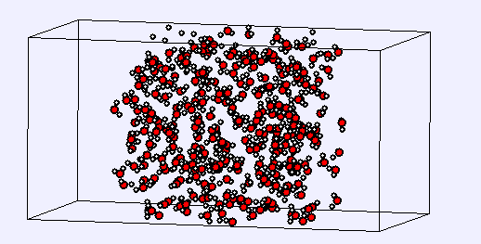

To calculate the density profile during the simulation you need to add the following command to your CONTROL file:

rdf 5
print rdf
zden

In general computing coexistence densities with a reasonable accuracy requires long runs. For this exercises you could use ~30,000 total steps and 10,000 steps for equilibration.

In order to perform this task you may find useful to read the following references: Error: Reference source not found and.

Compare your results with the experimental liquid-vapour coexistence curve of water.

Density maximum

The computation of the density maximum of SPC/E water can be done by performing simulations of bulk water at constant pressure (1 bar) and at different temperatures. To tackle this problem you may want to look at reference.

At which temperature does SPC/E exhibit a density maximum? What is the physical origin of the density maximum?

To rename a file within Linux use the command “mv”: “mv oldfilename newfilename”.
“emacs” is a very powerful editor that should be in your computer. Just try “emacs filename”, where filename is the file you want to edit.
References ? D. Eisenberg and W. Kauzmann, The Structure and Properties of Water, Clarendon Press – Oxford 1969 (new edition 2005).
H.J.C. Berendsen, J.R. Grigera and T.P. Straatsma, J. Phys. Chem., 91, 6269 (1987).
D. Frenkel and B. Smit, Understanding Molecular Simulation, From algorithms to applications, Academic Press, 1996.
M.P. Allen and D.J. Tildesley, Computer Simulation of Liquids, Clarendon Press – Oxford, 1989.
E. Sanz et. al., Phys. Rev. Lett., 92, 255701 (2004).
P. Atkins and J. de Paula, Physical Chemistry, Oxford University Press, 7th Edition.
A.K. Soper, F. Bruni and M.A. Ricci, J. Chem. Phys., 106, 247 (1997).
G.E. Walrafen, J. Chem. Phys., 40, 3249 (1964).
Y. Guissani, B. Guillot, J. Chem. Phys., 98, 8221 (1993).
A.K .Soper and M.G. Phillips, Chemical Physics, 107, 47 (1986).
J. Alejandre, D.J. Tildesley and G.A. Chapela, J. Chem. Phys., 102, 4574 (1995).
L. Haar, J.S. Gallagher and G.S. Kell, NBS/NRC Steam Tables, Hemispeher Washington DC 1984.
I. Brovchenko, A. Geiger and A. Oleinikova, J. Chem. Phys., 123, 044515 (2005).

