No. | Vibration | Description | Frequency | Intensity | Symmetry
1 | 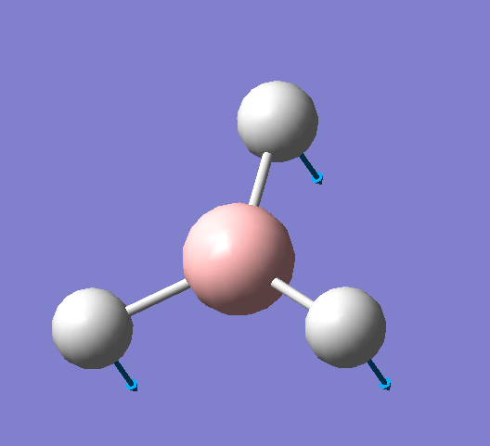 |  | 1145.71 cm⁻¹ | 92.6991
2 | 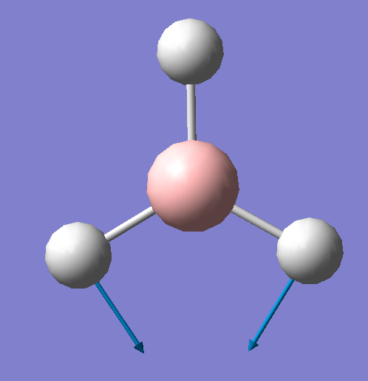 |  | 1204.66 cm⁻¹ | 12.3789
3 | 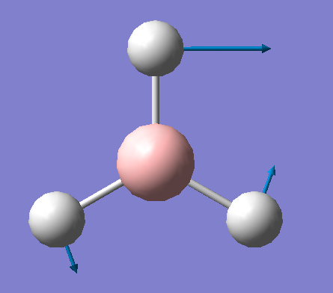 |  | 1204.66 cm⁻¹ | 12.3814
4 | 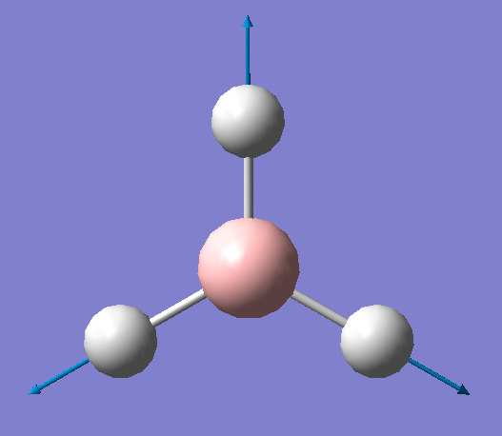 |  | 2592.79 cm⁻¹ | 0 | Totally symmetric  A₁’
5 | 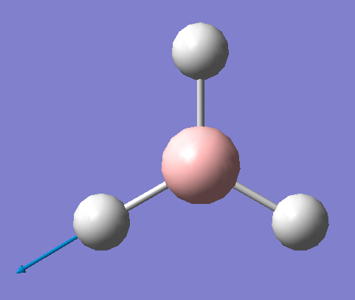 |  | 2731.31 cm⁻¹ | 103.837
6 | 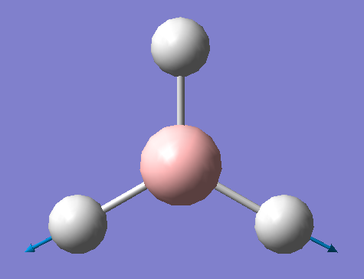 |  | 2731.31 cm⁻¹ | 103.830

